- Purpose
  - The purpose of this document is to describe the procedure for quality checking a Crewman High & Low Speed machine.
- Scope
  - This SOP applies to all equipment assembly team members. The process applies to the following machines:
E083015EQM0600BE1200 – Crewman 1600 RPM Cord-Electric Burnisher
E083015EQM0607BE1200 – Crewman 1600 RPM Cord-Electric Burnisher-Canada
E083016EQM0600BE1200 – Crewman 2000 RPM Cord-Electric Burnisher
E083016EQM0600BE1200 – Crewman 2000 RPM Cord-Electric Burnisher-Canada
E083013EQM0600BE1200 – Crewman 17HD Heavy Duty Floor Machine 17”
E083013EQM0607BE1200 – Crewman 17HD Heavy Duty Floor Machine 17”-Canada
E083014EQM0600BE1200 – Crewman 20HD Heavy Duty Floor Machine 20”
E083014EQM0607BE1200 – Crewman 20HD Heavy Duty Floor Machine 20”-Canada
E085812EQM0600BE1200 – Basic Dragon Dustless Floor Machine
- Responsibilities
  - The operations manager/supervisor is responsible for enforcing SOP.
- Materials
  - Load Tester
  - Hi-Pot Tester
- Definitions

- Procedure
  - If the machine being tested is a low speed machine (83013 or 83014) use the appropriate pad driver for this test. If the machine is a high speed machine (83015 or 83016) attach a pad for the test.

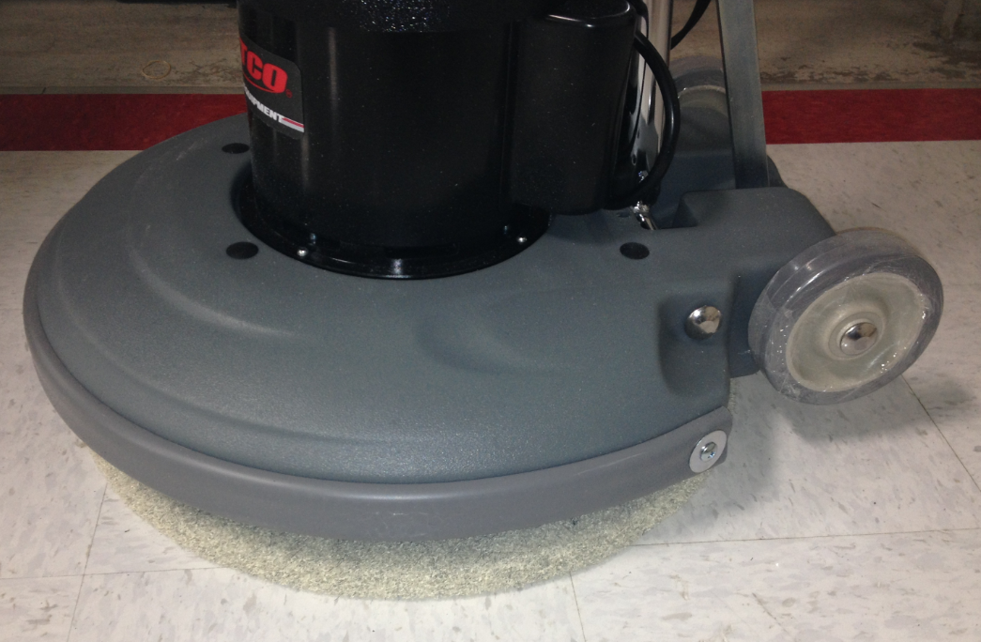
  - Place the pad or pad driver onto the machine. Unlock the cam handle and lower the handle to the operating position. Lock the handle in place.

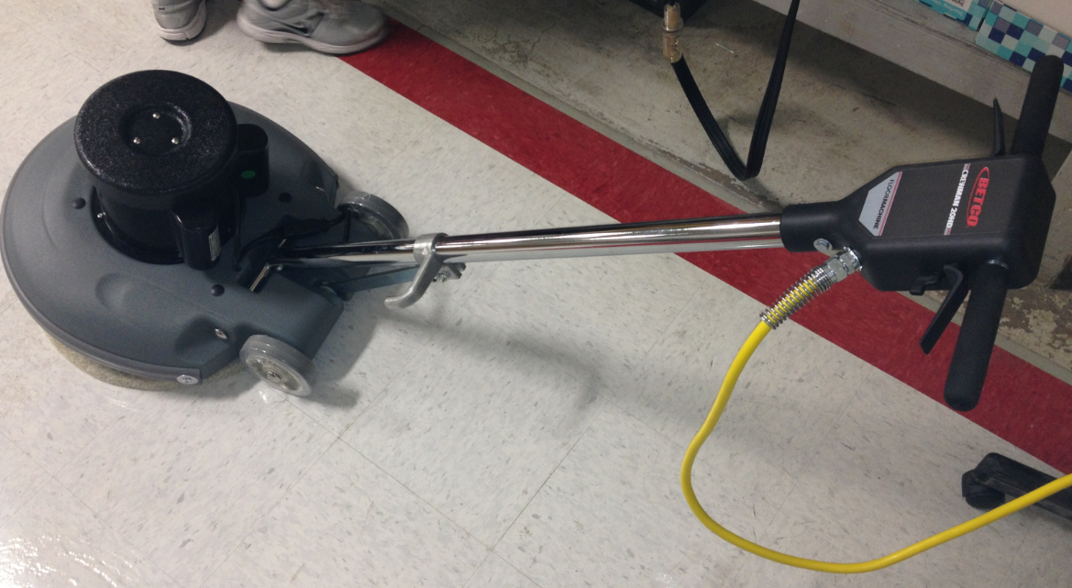

  - Turn on the Hi-Pot test unit. Plug the machine into the outlet that goes to the tester.

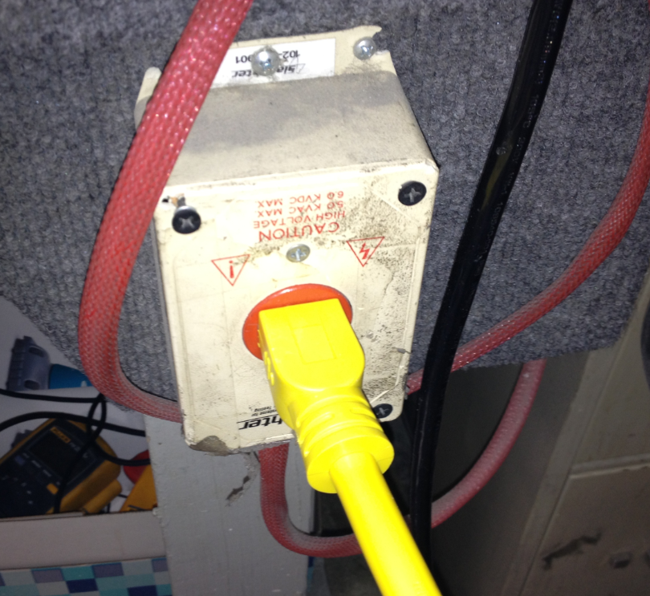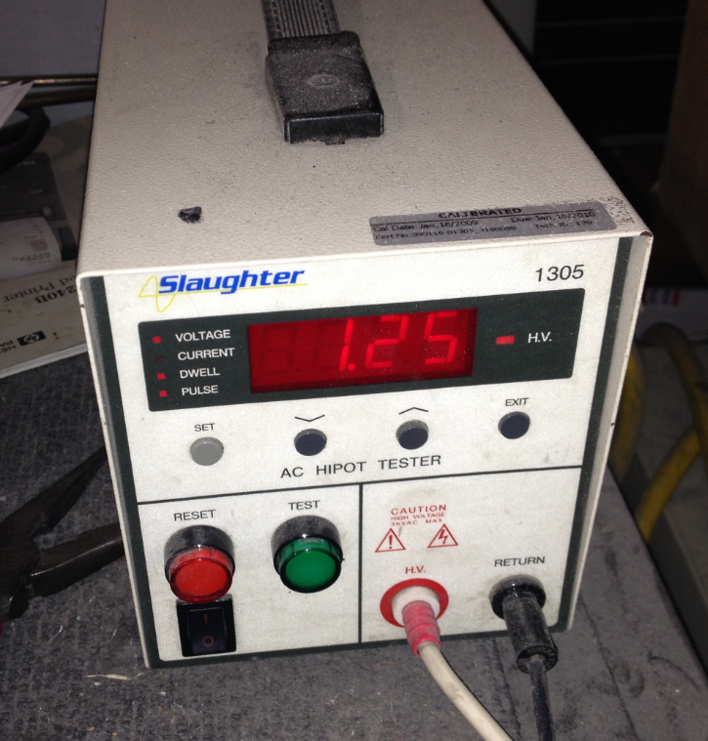

  - Press the green test button on the hi-pot tester. The unit will make a chirping sound. If a buzzer sounds, the machine is wired improperly and should be fixed. As long as the buzzer does not sound, the machine is ok.

  - Plug the end of the appliance load tester into a standard outlet. Plug the machine into the load tester. Verify that the load tester is set on Amps.

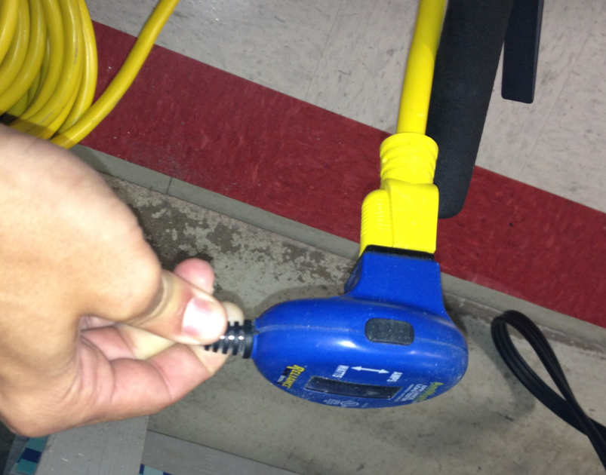

  - Operate the machine and make note of the amp draw displayed on the meter. Verify that the machine will also start and operate by using one hand. A new switch may need to be used if this condition is not met. Note: High Speed range must be <20 amps, Low Speed Range must be <10 amps.

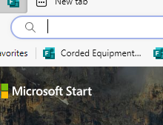
  - Next log into computer and click on Corded Equipment at the top of the page. Record the date, Machine ID, Serial Number, Amperage and pass or fail for Hipot Test. Note: If a failure occurs take a picture and upload into forms.

  - Unplug the machine, raise the handle into the transport position, and place a serial number sticker (81180) onto the back of the handle.

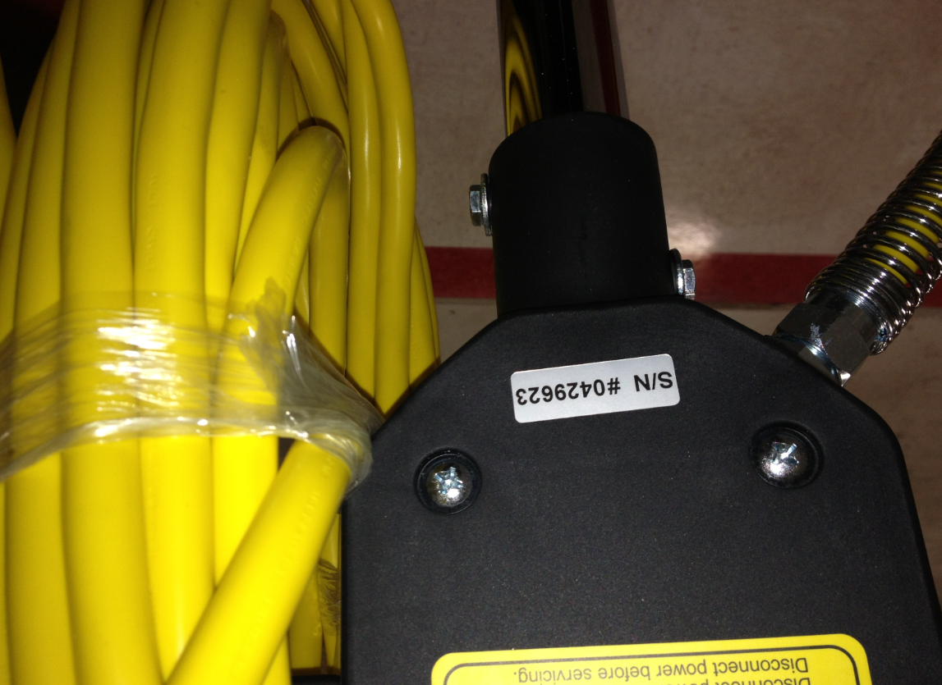

  - Remove the pad or pad driver.
  - Place a manual, a warranty card, and a tech service card into a plastic bag. Put the bag with the machine.
  - All low speed machines need to ship with a pad driver. The 20” machines (83014) get pad driver 81147 and the 17” machines (83013) get pad driver 81148. The Basic Floor machine also gets a pad driver (83185).

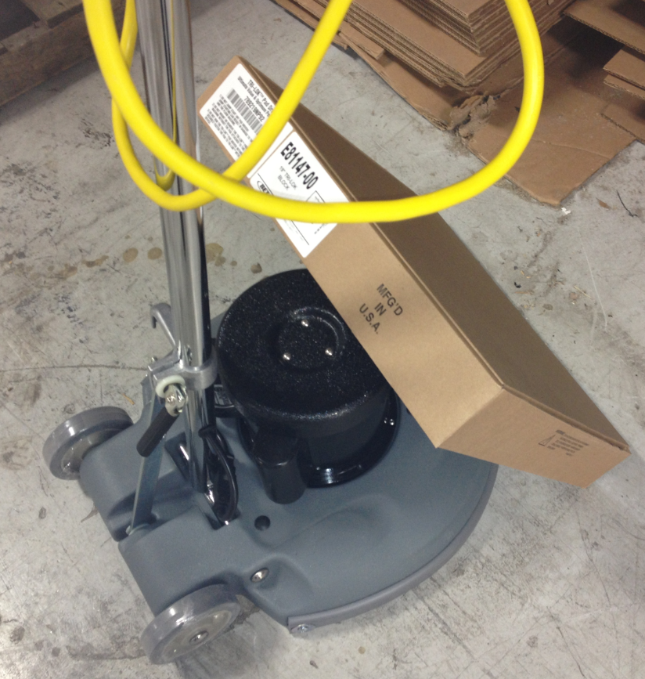

  - The machine is now ready to be boxed.
- References (optional section as needed)

- Training Guide

Functional Training Groups Requiring Training

- SOP Change Control

Date of Change | Reason for Change
Rev 01 - 11/19/2013 | This is the first version of the S.O.P. hence there are no revisions to this document.
Rev 02 - 1/12/2018 | Added Responsibilities Section
Rev 03 - 3/14/2025 | Removed work center notes and added new recording method on computer

Approvals

Submitter/Author Approval:__________________________________ Date:______________________

Management Approval:______________________________________ Date:______________________

QAU Approval:_____________________________________________ Date:______________________

